KNIGHT’S TOUR ON A CHESS BOARD

K

K
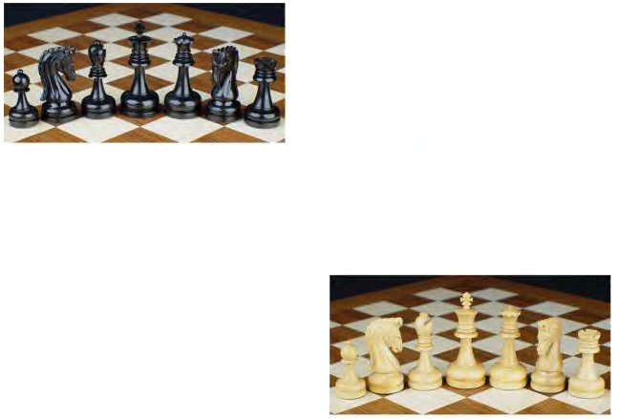
11
36
55
24
1
3
26
56
34
53
22
9
52
21
46
19
32
33
27
37
23
2
8
35
12
57
14
51
20
54
62
39
41
64
43
58
25
60
61
59
42
44
40
38
45
63
13
10
15
50
6
4
31
29
48
17
28
47
16
7
5
30
49
18

SAMPLE TOURS OF THE KNIGHT

INTRODUCTION

The Knight's Tour is a classic chess problem, which was studied (and probably solved) over 1000 years ago. The famous mathematician, Euler, published the first rigid mathematical analysis of the problem in 1759. Here's the problem: From an arbitrary starting position, move a Knight Chess piece around a chess board visiting all other squares on the board exactly once.

The goal of the Knight's Tour is to construct a path from an arbitrary position on the chessboard such that it visits each square on the board exactly once. A successful move is a move to a square not previously visited. After we have moved 64 times (counting the initial knight placement as move number 1), we have solved the problem.

KNIGHT’S EARLY HISTORY

The Islamic Empire was at its height around 800 AD, extending from North Africa to northern India, and its capital Baghdad was probably the largest city in the world at the time. The discovery that the knight could make such a tour of the chessboard, wherever it may have been made, would soon have made its way to the capital. In his 1902 article in the British Chess Magazine, the chess historian H.J.R. Murray was of the opinion that Rudrata's half-board tour was the earliest known knight's tour, by 1930 his view had changed to the above tour by Adli (Shatranj).

The earliest Indian knight's tour is that given on a half-chessboard
in the verse work Kavyalankara by the Kashmirian poet Rudrata,
ascribed to the reign of Sankaravarman, 884 – 903 AD. Many more knight tours were not recorded but the game is remembered as verses both by Indian chess players and the Arabians. It is hard to tell from history where exactly the game was originated and who found the tour by the knight as many times the game is taught from person to person. Most of the times the solutions were formed in verses and memorized, but not recorded.

EARLY SOLUTIONS OF KNIGHT’S TOURS

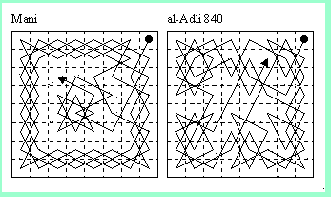

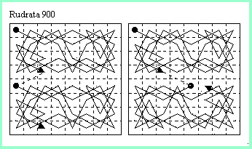

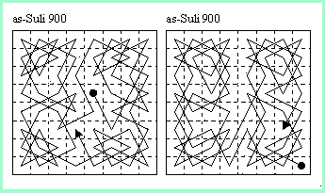

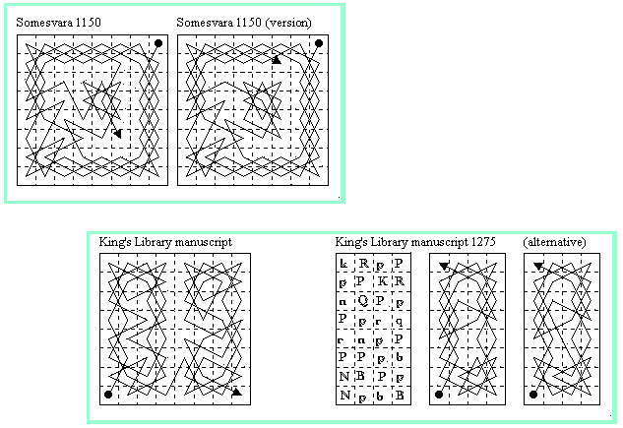

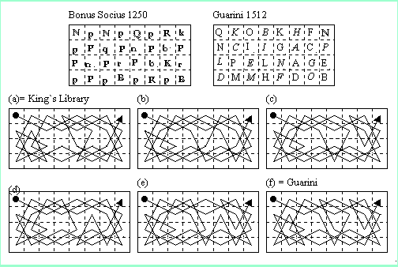

A HEURISTIC APPROACH

A technique known as Warnsdorf's heuristic allows us to make much better choices for next move than random selection. The heuristic, discovered by H. C. von Warnsdorf in 1823 tells to select as our next move the one which has the fewest choices for moving on from there. The heuristic tells us to select as our next move the one that has the fewest choices for moving on from there. At each step the knight must move to that square which has the lowest degree (the degree of a square is the number of squares to which the knight can move from that square). The rational for this is that towards the end, we will be left with squares have a high degree, and so there is a smaller chance of arriving at a square from which there no move.

Possible moves for a knight from current location (x, y):

(x-1, y+2) (x+1, y+2)

1

8

2

7
(x-2, y+1 ) (x+2, y+1)

K

3

6
(x-2, y-1) (x+2, y-1)
4

5

(x-1, y-2) (x+1, y-2)

Accessibility chart:

Accessibility with numbers indicating from how many squares each particular square is accessible.

2
3
4
4
4
4
3
2

3
3
4
6
6
4
6
6

4
4
6
8
6
8
8
8

4
4
8
6
8
8
8
6
4
4
8
8
6
8
8
6

4
8
4
8
6
8
6
8

3
4
3
4
6
6
6
6

2
4
3
4
4
4
2
3

GENERAL STRATEGY

- Start from one of the edge squares (but not one of the corner squares).
- Keep close to the edges of the board, and avoid the 16 central squares unless there are no alternatives.

- If the current position is one move away from a corner square, the next move should necessarily be to the corner squares.

- Follow the above guidelines until all edge squares and all squares bordering an edge square have been visited.

